## Discription of most expected invasive species

##### *Prorocentrum cordatum (Ostenfeld) J.D.Dodge, 1976*

**Phyllum:**Myzozoa  
**Class:** Dinophyceae  
**Order:** Prorocentrales  
**Family:** Prorocentraceae

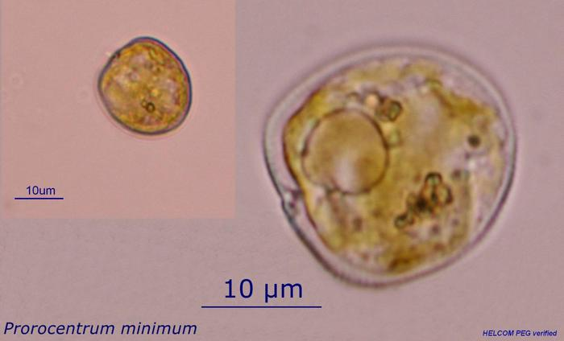

reference for figure

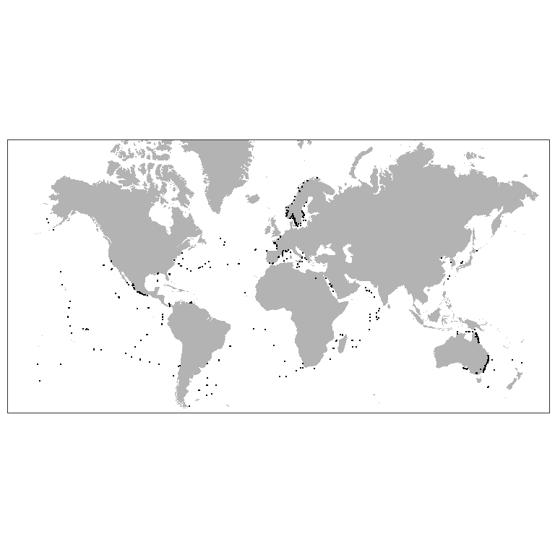

Figure ++. Worldwide distribution of Prorocentrum cordatum accordingly to GBIF.

*P. cordatum* (minimum) (Dinophyceae) was introduced in the Baltic Sea and caused recognizable environmental effect (Olenina et al., 2010)).[1] This species has wide salinity and temperature tolerance and low-light adaptation (Tyler, Seliger, 1981, Hajdu et al., 2005)[2] [3]. *P. minimum* was found also in the White Sea (Ilyash et al., 2018),[4] which proves it to be eurybiotic species. Is one of the red-tide-forming toxic species (Heil et al., 2005).[5] Being introduced into Ob Estuary *P. cordatum* may cause poisoning of the local aquatic organisms, especially in case of intensive warming. Besides that, may occupy spatial niches of native planktonic algae.

1. Olenina, I., Wasmund, N., Hajdu, S., Jurgensone, I., Gromisz, S., Kownacka, J., … Olenin, S. (2010). Assessing impacts of invasive phytoplankton: The Baltic Sea case. Marine Pollution Bulletin, 60(10), 1691–1700.
2. Tyler, M. A., & Seliger, H. (1981). Selection for a red tide organism: Physiological responses to the physical environment 1, 2. Limnology and Oceanography, 26(2), 310–324.
3. Hajdu, S., Pertola, S., & Kuosa, H. (2005). Prorocentrum minimum (Dinophyceae) in the Baltic Sea: morphology, occurrence—a review. Harmful algae, 4(3), 471–480.
4. Ilyash, L. V., Belevich, T. A., Zhitina, L. S., Radchenko, I. G., & Ratkova, T. N. (2018). Phytoplankton of the White sea. Dalam Biogeochemistry of the atmosphere, ice and water of the White Sea (hlm. 187–222). Springer.
5. Heil, C. A., Glibert, P. M., & Fan, C. (2005). Prorocentrum minimum (Pavillard) Schiller: a review of a harmful algal bloom species of growing worldwide importance. Harmful Algae, 4(3), 449–470.